**CookBook: Your Virtual Kitchen Assistant:**

**TEAM MEMBERS:**

**TEAM LEADER: THIRUMANI M**

**TEAM MEMBER: ARAVIND V**

**TEAM MEMBER: MADHESH S**

**TEAM MEMBER: SANJAI S**

**TEAM MEMBER: SUDHARSHAN B**

**INSIGHTSTREAMING (React)**

**1. Introduction**

Overview

A food recipes app is a digital platform that provides users with access to a wide range of recipes, cooking instructions, and meal-planning tools. The app serves as a virtual cookbook, offering convenience, personalization, and an interactive cooking experience for users of all skill levels.

Project Purpose

**T**he purpose of developing a food recipes app is to provide users with an interactive and user-friendly platform to discover, save, and prepare meals efficiently. The app aims to enhance the cooking experience by offering personalized recipes, step-by-step guidance, and meal planning tools.

Key Objectives:

1. Simplify Cooking for Users

Provide easy access to a wide variety of recipes with clear instructions.

Offer filters to find recipes based on available ingredients, cooking time, and dietary preferences

2. Proote Healthy & Smart Eating

Encourage users to cook at home rather than rely on processed or fast food.

Provide nutritional information for each recipe.

Offer meal planning features to support a balanced diet.

3. Enhance User Engagement & Experience

Enable users to save and organize favorite recipes.

Include step-by-step cooking tutorials with images or videos.

Allow users to rate, review, and share their cooking experiences.

4. Integrate Technology for Convenience

AI-based recipe recommendations based on user preferences.

Voice-guided cooking assistance for hands-free operation.

Offline access to saved recipes.

5. Monetization & Business Growth

Offer premium recipes, meal plans, or exclusive content via subscriptions.

Implement affiliate marketing for kitchen tools and ingredient purchases.

Provide advertising space for food brands and sponsors

6. Support a Community of Food Enthusiasts

Allow users to share their own recipes and modifications.

Create a social platform where users can follow chefs and interact.

Enable recipe challenges and competitions to encourage participation.

**2. Technologies Used**

Front-End Technologies

1. HTML – Structure of the web pages.

2. CSS – Styling for the web pages. CSS Flexbox and Grid are used for layout.

3. JavaScript – For dynamic content updates, fetching data from APIs, and updating the UI.

4. React.js – A popular JavaScript library for creating interactive apps.

5. Font Awesome – For the icons in the sidebar.

**3. Project Structure**

File Structure

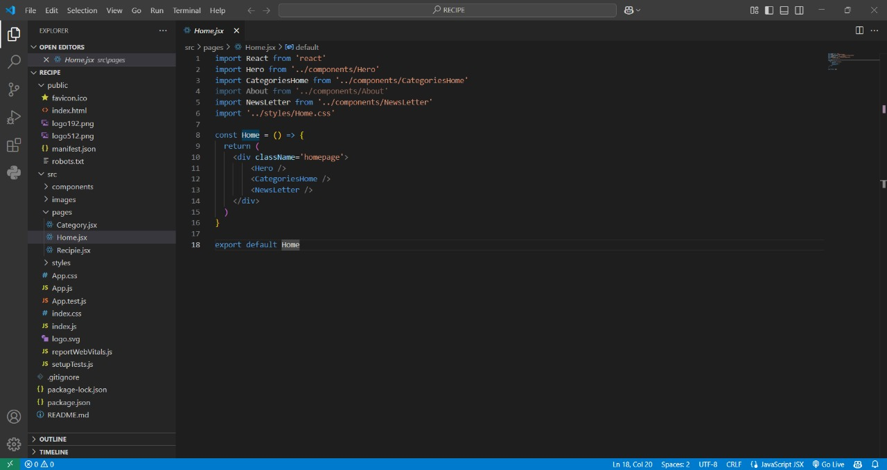

Key Files Overview

• index.html: Contains the structure of the main dashboard interface.

• styles.css: Defines the visual design of the application, including layout, colors, fonts, and responsiveness.

• script.js: Handles data fetching, UI population, and user interaction logic.

• logo.png: The logo used in the sidebar for the branding of Crypto Verse.

**4. Features**

Dashboard Overview

• Sidebar Navigation: Contains links to various pages or sections (e.g., Dashboard, Market Trends, etc.).

• Real-Time Updates: Displays live news.

• Search Functionality: Allows users to search for a specific news by name or category.

• Top 10 News: Displays a grid layout of the top 10 news by importance

**5. User Interface Design**

Sidebar Navigation

The sidebar is designed to be fixed on the left side of the screen. It includes:

• Branding with the application’s name.

• Navigation links to different sections of the dashboard.

• A logout button to navigate the user out of the system.

Main Content

The main content area is dynamically populated with:

* Top News: A panel with the top most news highlighted.
* Top News Panel: A grid displaying the top 10 news articles with their title.

**6. Project Flow**

Milestone 1: Project setup and configuration.

● Installation of required tools:

To build InsightStream, we'll need a developer's toolkit. We'll use React.js for the interactive interface, React Router Dom for seamless navigation, and Axios to fetch news data. For visual design, we'll choose either Bootstrap or Tailwind CSS for pre-built styles and icons.

Open the project folder to install necessary tools. In this project, we use:

o React Js

o React Router Dom

o React Icons

o Bootstrap/tailwind css

o Axios

Milestone 2: Project Development

❖ Setup the Routing paths

❖ Develop the Navbar and Hero components

❖ Code the popular categories components and fetch the categories from newsapi. ❖ Also, add the trending news in the home page.

❖ Additionally, we can add the component to subscribe for the newsletter and the footer.

❖ Now, develop the category page to display various news articles under the different categories.

**7. Project Execution:**

After completing the code, run the react application by using the command “npm start” or “npm run dev” if you are using vite.js

Here are some of the screenshots of the application.

* **Hero components**

In the hero component, the trending news articles are displayed. It is to highlight them. Apart from that, the search bar is also available to search for various articles and categories.



* **Popular categories**

In the hero component, the trending news articles are displayed. It is to highlight them. Apart from that, the search bar is also available to search for various articles and categories.

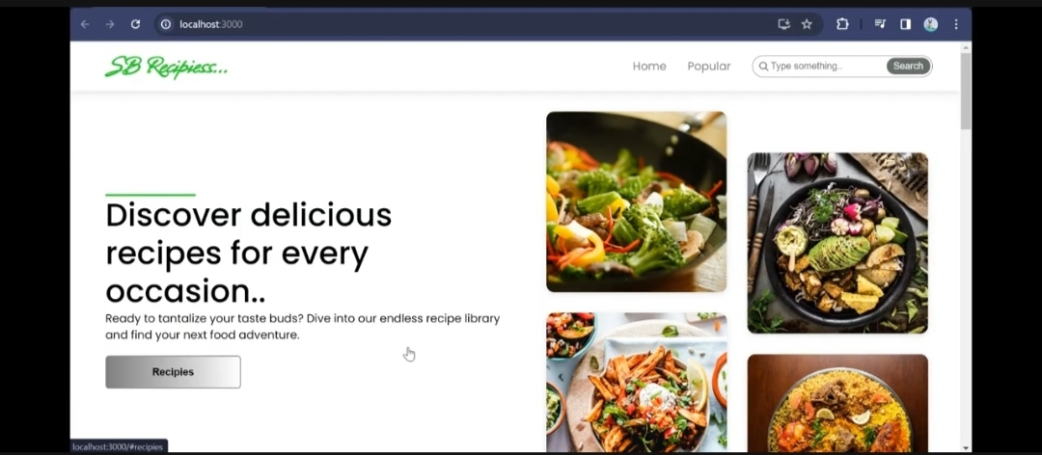

* **Category/Search result page**

Finding the news you crave is effortless with InsightStream. This page displays a neatly organized list of articles matching your chosen category or specific search query. Each entry would provide a clear headline, a concise summary, and if available, an image to give you a quick glimpse into the story. To further refine your exploration, filters or sorting options might be available. Imagine narrowing down results by date, source, keyword, or other relevant criteria to pinpoint exactly what you're looking for.

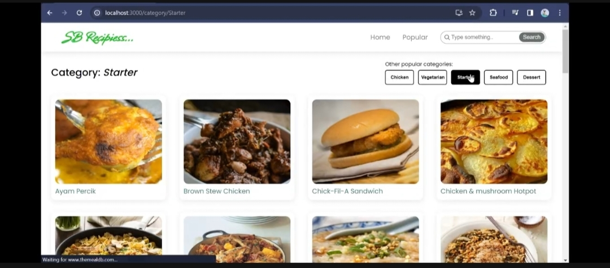

* **Redirected Article page**

This is where you dive deep! The article page proudly displays the complete news story, retrieved directly from the source. To keep you engaged and exploring related topics, the page might also suggest additional articles based on the current story. These suggestions can open doors to a world of interconnected information, allowing you to become a well-rounded news connoisseur.

**8. Testing**

Testing is conducted using:

• Manual Testing: Testing all features to ensure they work as expected.

• Functional Testing: Ensuring the functionality of each feature, including fetching and displaying data, chart rendering, and filtering.

**9. Conclusion**

A food recipes app serves as a powerful tool for individuals who enjoy cooking, want to explore new dishes, or aim to maintain a healthier lifestyle. By offering a vast collection of recipes, step-by-step guidance, personalized recommendations, and meal-planning features, the app simplifies the cooking experience and enhances user convenience.

With the integration of AI, smart kitchen devices, and community-driven content, the app can create an engaging ecosystem for food enthusiasts. Moreover, various monetization strategies, such as premium subscriptions, affiliate marketing, and sponsored content, make it a sustainable business model.

Overall, a food recipes app has the potential to transform the way people cook by making it more accessible, enjoyable, and efficient. It caters to both beginners and experienced cooks, fostering a digital space where culinary creativity thrives.